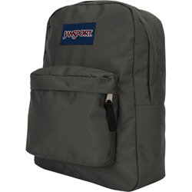
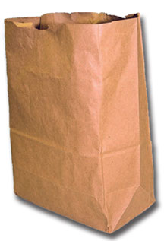
Skit in a Bag

- Fill pillow cases, backpacks, trash bags, brown paper shopping bags, etc. with random items
e. Printed Bible verse
f. Binoculars
g. Silly hats
h. Whatever you can find **

  - Duct tape
  - One shoe
  - Old phone
  - Small frying pan
- Divide the group into smaller groups
- Give each group a bag of items
(each groups bag has different items in it than the other groups do)
- The groups must come up with a skit using all of the items in their bag
(participation from every member of the group is generally required)
- Have each group perform their skits
- An unbiased judges panel can be assembled to decide which group had the best skit often makes for goodhearted competition and fun
- Including Bible verses as items in each bag may be a great way to segue into the following message!

HAVE FUN!!!

